CHAPTER 1
INTRODUCTION
This project is a databased shopping system for an existing mall or shop. The objective of this mini project is to select the products in software which the customers wants to buy. The details of the products are stored in database system.
The database management system is used as backend. For backend we have used XAMPP tool to access the database and servers. The XAMPP provides the servers and sql database. The shops or shopping mall can store their products details with the price and discount and also with the rating of that product. They can access the data of the products easily. The programmer doesn’t need to code every time in programme while adding new products or modifying them. The new products are easily added in database and the added products are displayed with the price, the image of the product, name of the product, discount and ratings.
All the details of the products are added in the database. The XAMPP tool provides the Apache server and SQL database to create our own database and access it through the server. New products can be inserted through the database without modifying any code. This saves the time of the programmer and we can add new products, modify the existing products and delete the existing products which are not required. The details of products can be edited instantly. The data will be stored in the server. We can create n number of tables, n number of rows and columns. The created data will be stored.
The Shopping project has been developed to allow business grows larger and faster. The database management system is used as backend. For backend we have used XAMP tool to access the database and servers. The XAMP provides the servers and sql database. The shops or shopping mall can store their products details with the price and discount and also with the rating of that product. They can access the data of the products easily.
Objectives:
The programmer doesn’t need to code every time in . New products can be inserted through the database without modifying any code. This saves the time of the programmer and we can add new products, modify the existing products and delete the existing products which are not required. Grammar while adding new products or modifying them. The new products are easily added in database and the added products are displayed. This system is developed as our company requirements. Shopping Cart is a very important feature used in e-commerce.
Shopping is a store that enables website owners to sell their products in the store. It is a web shopping cart that web enables the day-day sales functions. The System helps the Customer to purchase the products with and without Credit – Card Information. It includes sophisticated product and customer management modules. This website will be useful to anyone who wants to purchase items using internet. Generates the Reports related to the system. This system is developed as our company requirements. Shopping Cart is a very important feature used in e-commerce to assist people making purchases any products. This project deals with developing an e-commerce website for different types of product. It provides the user with the catalog of different types of products available for purchase in the store.
ADMINISTRATIVE
This module is the main module which performs all the main operations in the system. The major operations in the system are:
Admin login
Add/Delete/Update/View/Save Employee
User module
Item module
Customer module
Distributor module
Stock Module
Shopping Mall Management System project is a desktop application which is developed in Java platform.

Mall Administration
The Mall Administrator is the super user and has complete control over all the activities that can be performed. The application notifies the administrator of all shop creation requests, and the administrator can then approve or reject them. The administrator also manages the list of available product categories. The administrator can also view and delete entries in the guestbook.
Shopping owner
Any user can submit a shop creation request through the application. When the request is approved by the Mall Administrator, the requester is notified, and from there on is given the role of Shop Owner. The Shop Owner is responsible for setting up the shop and maintaining it. The job involves managing the sub-categories of the items in the shop. Also, the shop owner can add or remove items from his shop. The Shop Owner can view different reports that give details of the sales and orders specific to his shop. The Shop Owner can also decide to close shop and remove it from the mall.
Mall Customer/Guest
A Mall Customer can browse through the shops and choose products to place in a virtual shopping cart. The shopping cart details can be viewed and items can be removed from the cart. To proceed with the purchase, the customer is prompted to login. Also, the customer can modify personal profile information (such as phone number and shipping address) stored by the application. The customer can also view the status of any previous orders, and cancel any order that has not been shipped yet.
Employees
Purchase department under a Purchase manager to overlook purchasing activities if warehousing needs arise. Sales department under a Sales manager who will look after the sale of products and services, the most important activity. Accounts department under an Accounts manager to look after the accounting activities of the enterprise. Any user can submit a shop creation request through the application. When the request is approved by the Mall Administrator, the requester is notified, and from there on is given the role of Shop Owner. Shopping is a store that enables website owners to sell their products in the store. It is a web shopping cart that web enables the day-day sales functions. The System helps the Customer to purchase the products with and without system.

CHAPTER 2
2.1 EXISTING SYSTEM
In this existing system the details of the products are added by modifying the code. Here the data cannot be stored and cannot be accessed whenever we need, modifying the code again and again will be the time consuming and data loss will occur. In this system we cannot store the n number of tables of n number of rows and columns. It will be difficult to add the new products or modify the products or delete the products instantly. Here the editing of the products details will be time consuming. The description of the product will be also limited.
Online shopping is the process of buying goods and services from merchants who sell on the Internet and people can purchase just about anything from companies that provide their products online. Online shopping is a form of Electronic Commerce . E-commerce or Electronic commerce,
2.2 PROPOSED SYSTEM
In the proposed system we are database management system to store the data and retrieve the data. Here the XAMPP tool is used for server and database. The XAMPP tool provides Apache server, MySql database, Filezilla application, Mercury server, Tomcat. We have used the Apache server and MySql database. The database is used as backend and php, html, javascript are used as front end. Here there is no modifying of code everytime to enter or modify the details of product. This is the least time consuming method and easiest method to insert new products or modify the products.
This is also very user friendly to use this method. XAMPP is a free and open-source cross-platform web server solution stack package developed by Apache Friends, consisting mainly of the Apache HTTP Server, Maria DB database, and interpreters for scripts written in the PHP and Perl programming languages. Since most actual web server deployments use the same components as XAMPP, it makes transitioning from a local test server to a live server possible.

CHAPTER 3
SOFTWARE REQUIREMENT AND SPECIFICATIONS

The software requirements document is an official statement of what the system developers should implement. It is both the user requirements for the system and a detailed specification of the system requirements.
3.1 Functional Requirements
A shop owner should be able to register in the first page of the application, and mention their name, phone number, discount of the item, cost of the item, quality of the item, amount of the item etc., which can be viewed and updated.
3.2 Non Functional Requirement
Usability
The responses obtained within seconds. The software must have a simple, user-friendly interface so customers can save time and confusion. As the project is made using php, it has fast loading time then the website made using any other language.
Reliability
The system is more reliable because of the qualities that are inherited from the chosen platform php. The code built by using php is more reliable.
Supportability
The system is designed to be the cross platform supportable. The system is supported on a wide range of hardware and any software platform. This application is being developed using XAMPP, hence it is extremely portable.
Implementation
The system is implemented in web environment. The apache server is used as the web server and windows XP/vista/7/10 is used as the platform.
Interface
The user interface is based on the web browser. The application is developed using HTML, CSS, BOOTSTRAP. The interface design is aimed at a flexible front-end communication to provide the user with clear information in navigating a user-friendly interface is planned.

3.3 Performance Requirements
The complete information about the items in the shop with good quality and discount.The response to the user is within seconds, providing all information at a galance.

3.4 HARDWARE REQUIREMENT
- Processor: Pentium 4 2GHz and above
- RAM: 2GB RAM
- Monitor: 15’’ Colour monitor
- Keyboard
- Mouse

3.5 SOFTWARE REQUIREMENT
- Operating System: Windows 7 above
- User Interface: HTML, CSS.
- Programming Language: PHP, Javascript.
- Tool: XAMPP
- Server: Apache
- Database: MySQL

CHAPTER 4
TECHNOLOGIES USED

XAMPP TOOL

XAMPP is a free and open-source cross-platform web server solution stack package developed by Apache Friends, consisting mainly of the Apache HTTP Server, Maria DB database, and interpreters for scripts written in the PHP and Perl programming languages. Since most actual web server deployments use the same components as XAMPP, it makes transitioning from a local test server to a live server possible.

The term can be unofficially broken down as follows:
X | as an ideographic letter referring to cross-platform
A | Apache or its expanded form, Apache HTTP Server
M | MariaDB (formerly: MySQL)
P | PHP
P | PERL

APACHE SERVER

Apache is an open-source and free web server software that powers around 46% of website around the world. The official name is Apache HTTP Server, and it’s maintained and developed by the Apache Software Foundation. It allows website owners to serve content on the web — hence the name “web server”. It’s one of the oldest and most reliable web servers, with the first version released more than 20 years ago, in 1995.When someone wants to visit a website, they enter a domain name into the address bar of their browser. Then, the web server delivers the requested files by acting as a virtual delivery man. Although we call Apache a web server, it is not a physical server, but rather a software that runs on a server. Its job is to establish a connection between a server and the browsers of website visitors (Firefox, Google Chrome, Safari, etc.) while delivering files back and forth between them (client-server structure). Apache is a cross-platform software, therefore it works on both Unix and Windows servers.

When a visitor wants to load a page on your website, for instance, the homepage or your “About Us” page, their browser sends a request to your server and Apache returns a response with all the requested files (text, images, etc.). The server and the client communicate through the HTTP protocol and Apache is responsible for the smooth and secure communication between the two machines. Apache is highly customizable, as it has a module-based structure. Modules allow server administrators to turn additional functionalities on and off.

MySQL

MySQL is the most popular Open Source Relational SQL Database Management System. MySQL is one of the best RDBMS being used for developing various web-based software applications. MySQL is developed, marketed and supported by MySQL AB, which is a Swedish company.
MySQL is a database system used on the web
MySQL is a database system that runs on a server
MySQL is ideal for both small and large applications
MySQL is very fast, reliable, and easy to use
MySQL uses standard SQL
MySQL compiles on a number of platforms
MySQL is free to download and use
MySQL is developed, distributed, and supported by Oracle Corporation

PHP

PHP stands for Hypertext Preprocessor. PHP is an interpreted language, i.e., there is no need for compilation .PHP is a server-side scripting language. PHP is faster than other scripting languages, for example, ASP and JSP. PHP is a widely used server-side programming language that’s become increasingly fast and powerful over the years. PHP works well with HTML and databases, making it a great language for anyone interested in building dynamic web applications.
HTML
Hypertext Markup Language (HTML) is the standard markup language for documents designed to be displayed in a web browser. It can be assisted by technologies such as Cascading Style Sheets (CSS) and scripting languages such as JavaScript.Web browsers receive HTML documents from a web server or from local storage and render the documents into multimedia web pages. HTML describes the structure of a web page semantically and originally included cues for the appearance of the document.
HTML elements are the building blocks of HTML pages. With HTML constructs, images and other objects such as interactive forms may be embedded into the rendered page. HTML provides a means to create structured documents by denoting structural semantics for text such as headings, paragraphs, lists, links, quotes and other items. HTML elements are delineated by tags, written using angle brackets. Tags such as <img /> and <input /> directly introduce content into the page. Other tags such as <p> surround and provide information about document text and may include other tags as sub-elements. Browsers do not display the HTML tags, but use them to interpret the content of the page.HTML can embed programs written in a scripting language such as JavaScript, which affects the behavior and content of web pages. Inclusion of CSS defines the look and layout of content.

CSS
Cascading Style Sheets (CSS) is a style sheet language used to describe the presentation of a document written in HTML or XML (including XML dialects such as SVG, MathML or XHTML). CSS describes how elements should be rendered on screen, on paper, in speech, or on other media. CSS is the language for describing the presentation of Web pages, including colors, layout, and fonts. It allows one to adapt the presentation to different types of devices, such as large screens, small screens, or printers. CSS is independent of HTML and can be used with any XML-based markup language. CSS also defines non-visual styles, such as reading speed and emphasis for aural text readers. The selector points to the HTML element you want to style. The declaration block contains one or more declarations separated by semicolon.
CHAPTER 5
IMPLENTATION

SAMPLE CODE
<!DOCTYPE html>
<html>
<head>
<title></title>
<meta charset="utf-8">
<meta name="viewport" content="width=device-width, initial-scale=1">
<link rel="stylesheet" href="https://maxcdn.bootstrapcdn.com/bootstrap/4.1.3/css/bootstrap.min.css">
<script src="https://ajax.googleapis.com/ajax/libs/jquery/3.3.1/jquery.min.js"></script>
<script src="https://cdnjs.cloudflare.com/ajax/libs/popper.js/1.14.3/umd/popper.min.js"></script>
<script src="https://maxcdn.bootstrapcdn.com/bootstrap/4.1.3/js/bootstrap.min.js"></script>
<link rel="stylesheet" href="https://cdnjs.cloudflare.com/ajax/libs/font-awesome/4.7.0/css/font-awesome.min.css">
<link href="https://fonts.googleapis.com/css?family=Abril+Fatface|Dancing+Script" rel="stylesheet">
</head>
<body class="container">
<h1 class="text-center text-danger mb-5"
style="font-family: 'Abril Fatface', cursive;"> SHOPPING MALL MANAGMENT SYSTEM</h1>
<div class="row">
<?PHP
$con = mysqli_connect('localhost','root');
mysqli_select_db($con,'shopping');
// if($con){
// echo "connection successful";
//}else{
//echo "no connection";
//}
$query = " SELECT `name`, `image`, `price`, `discount` FROM `products` order by id ASC ";
$queryfire = mysqli_query($con, $query);
$num = mysqli_num_rows($queryfire);
if($num > 0){
while($products = mysqli_fetch_array($queryfire))
{
<div class="col-lg-3 col-md-3 col-sm-12">
<form>
<div class="card">
<div class="card">
<h6 class="card-title bg-info text-white p-2 text-uppercase">
<?php echo $products['name']; ?>
</h6><div class="card-body"><img src="<?php echo $products['image']; ?>" alt="phone" class="img-fluid mb-2">
<h6> &#8377; <?php echo $products['price']; ?><span> (<?php echo $products['discount']; ?>% off) </span> </h6>
<h6 class="badge badge-success"> 4.4 <i class="fa fa-star"> </i> </h6>
<input type="text" name="" class="form-control" placeholder="Quantity">
</div>
<div class="btn-group d-flex"><button class="btn btn-success flex-fill"> Add to cart </button> <button class="btn btn-warning flex-fill text-white"> Buy Now </button>
</div>
</div>
</form>
</div>
<?php
}
?>
</div>
</body>
</html>
CHAPTER 6
DESIGN AND ANALYSIS

The most creative and challenging face of the system development is System Design. It provides the understanding and procedural details necessary for the local and physical stages of development. In designing a new system, the system analyst must have a clear understanding of the objectives, which the designing is aiming to fulfill. The first step is to determine how the output is to be produced and in what format. Second, input data and master files have to be designed to meet the requirements of the proposed outputs. The operational phases are handled through program construction and testing.
Design of the system can be defined as a process of applying various techniquesand principles of the process of defining a device, a process, or a system in sufficient detail to permit its physical realization. Thus system design is a solution to “how to” approach to the creation of the new system. This important phase provides the understanding and the procedural details necessary for implementing the system recommended in the feasibility study. The design step provides a data design, and a procedural design.

6.1 USE CASE DIAGRAMS
A use case diagram is a graphical depiction of the interactions among the elements of a system. A use case is a methodology used in the system analysis to identify, clarify, and organize system requirements. The use cases, which are the specific roles played by the actors within and around the system. In this context, the term system refers to something being developed or operated, such as mail-order product sales and service.
System objectives can include planning overall requirements, validating a hardware design, testing and debugging a software product under development, creating an online help references, or performing a customer service oriented task. Use case in a product sales environment would include item ordering, catalog updating, payment processing, and customer relations. Use case diagrams are used to gather the requirements of a system including internal and external influences. These are mostly design requirements. Hence, when a system is analysed to gather its functionalities, use cases are prepared and actors are identified. An important part of the Unified Modeling Language is the capability for drawing use case diagrams. Use cases are used during the analysis phase of a project to identify system functionality. They separate the system into actors and use cases. Actors represents roles that are played by users of the system. It does not show the details of the use cases. It does not show the order in which steps are performed to achieve the goals of each use case. It is used to identify the requirements of a system.

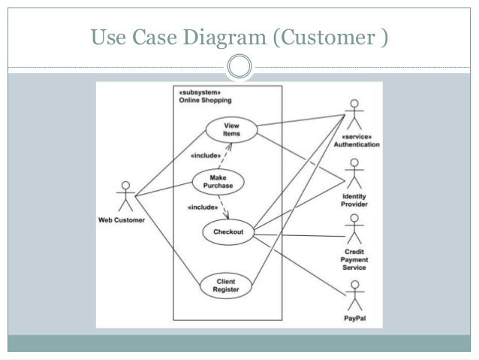

Fig6.1.1 Use case diagram of customer
The boundary, which defines the system of interest in relation to the world aroundit. The actors, usually individuals involved with the system defined according to their roles.The use cases, which are the specific roles played by the actors within and around the system. Web Customer actor uses some web site to make purchases online. Top level use cases are View Items, Make Purchase and Client Register. View Items use case could be used by customer as top level use case if customer only wants to find and see some products. This use case could also be used as a part of Make Purchase use case. Client Register use case allows customer to register on the web site, for example to get some coupons or be invited to private sales. Note, that Checkout use case is included use case not available by itself - checkout is part of making purchase. View Items use case is extended by several optional use cases - customer may search for items, browse catalog, view items recommended for him/her, add items to shopping cart or wish list. All these use cases are extending use cases because they provide some optional functions allowing customer to find item. Customer Authentication use case is included in View Recommended Items and Add to Wish List because both require the customer to be authenticated. At the same time, item could be added to the shopping cart without user authentication.
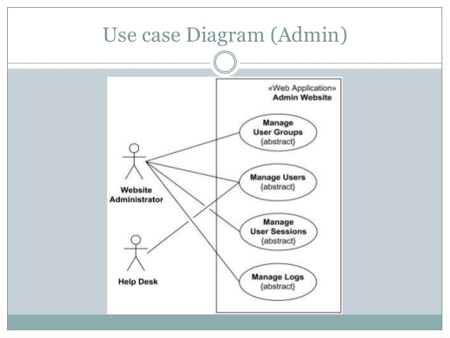
6.1.2 Use case diagram of Admin
Administrator can check for the space availability in the parking complex and thereby increases or decreases the number of parking slots. Depending on the parking statistics like whether there are more number of cars two wheelers he/she can decide upon how to allot spaces and manages the parking space. So as to fit maximum number of vehicles (Administrator can search for a owner’s vehicle by entering the vehicle number). The maintenance of the system is done by the admin. (e.g. recovery from faults like improper parking of the vehicles). The admins in the shopping mall is Web Administrator and Help Desk. Admin Websites are the abstracts. The Web Applications in the Admin Website are Manage User Groups, Manage Users, Manager User Sessions and Manage Logs. The Web Administrator which is connected to the three abstracts they are Manage User Groups, Manager User Sessions and Manage Logs. The Help Desk which is connected to the single abstract that is Manage User. The Help Desk which takes the information even from the Website Administrator. The Use Case UML diagram for the "Administrator" actor User scenario name: Administrator uses the system Actor: Administrator Scenario Steps Administrator wants to add an entity. System gives the entity types. Administrator adds an actor / a course / an exam. System records the information. Administrator wants to edit an entity. System gives the entity types. Administrator edits an actor / a course / an exam.
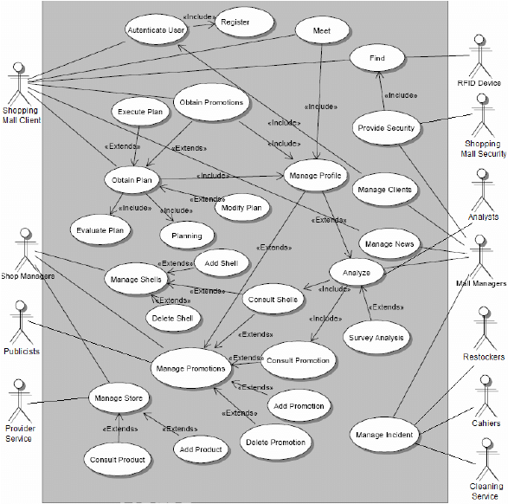
Fig6.1.3 Use case diagram for the Shopping Mall

Use Case Diagram for the Shopping Mall Example Personalization is a value-

added service to the traditional commerce techniques. Nowadays users demand personalized

services. To provide them, the system needs to identify clients in a transparent and ubiquitous

manner (the growing use of handheld devices is a great opportunity to interact with the

clients in a simple way) and to manage the clients profiles (preferences, habits, etc.). When a

client visits the mall, usually is looking for a product or service. A personal agent installed in

his/her personal device can gain access to the services provided in the mall. The client has to

be authenticated and his/her personal profile (and not his/her personal data) is then obtained.

Security is an important issue in open systems. Once the client has been authenticated,

automatically receives personalized offers in the handheld device.
6.2 E-R diagram
Product_ID
Product_name
price
Ratings
Discount
Products

Fig 1 : E-R diagram

The figure 1 which shows the E-R diagram of our database. ER Model is used to model the logical view of the system from data perspective which consists of these components:
Entity Type, Entity Set –
An Entity may be an object with a physical existence – a particular person, car, house, or employee – or it may be an object with a conceptual existence – a company, a job, or a university course. An Entity is an object of Entity Type and set of all entities is called as entity set. e.g.; E1 is an entity having Entity Type Student and set of all students is called Entity Set. Here Products is the entity type with its attributes Product_ID, Product_name, Price, Discount, Ratings. Product_ID is the primary key and it is underlined in the diagram because it is a primary key. The attribute which uniquely identifies each entity in the entity set is called Primary key. The Product_ID cannot be same and it has to be unique. In ER diagram, primary key attribute is represented by an oval with underlying lines.
Tenant Officer View Edit Add Logout Warning C1 New maintenance New Rental Payment Rental Payment Floor Plan Change Password Rental Contract Maintenance Record Login Table Rental Contract Details Unit Type Classification Unit Complaints Unit Maintenance Rental Payment Record Rental Revenue Record Rental Contract Details Unit Complaint Table Unit Maintenance Table Rental Contract Details. Finance Officer View Add Logout Warning C1 Miscellaneous Expense Miscellaneous Revenue Profit Change Password Loss Maintenance Expense Record Login Table Loss Revenue Expense Logistics Individual View Profit Maintenance Revenue Record Revenue Expense Logistics Individual View.
Human Resource Officer View Edit Add Logout Warning C1 New Employee New Overtime New Employment Employment Market Info Change Password Salary Employee Record Login Table Salary Details Table Employee Statistics Overtime Employee Details Employment Details Overtime Record Employee Statistics Overtime Tables Employee Record Employee Details Employee Details Employment Market Record Employment Market Info Unit Maintenance Unit Maintenance Record Employment Market Record. Mall Manager View Logout Warning C1 Employee Over All View Change Password Employee Individual View Logistics Individual Login Table Employee Individual Salary Details Revenue/ Expense Profit/loss Employee Over All Logistics Over All Salary Details Unit Complaint Table Unit Maintenance Table Floor Plan Logistics Individual view Logistics Over All view Facility Maintenance Facility Maintenance. Tenant Logout Reminder C1 Lodge A Complaint Change Password Booking Record Login Table Upload Shop Logo Upload Advertisement Unit Complaint Table Shop Details Cancel Bay Booking Book Loading Bay View Bay Booking Contract & Rental Payment Contract & Rental Payment Details. Facility Officer View Edit Add Logout Warning C1 New maintenance New Rental Payment Logistics Replacement Record Logistics Item Details Change Password Facilities Maintenance Record Login Table Facilities Details Table Facility Maintenance Logistics Over All View Logistics Individual View Logistics Replenishment Table Rental Revenue Record Rental Contract Details Unit Complaint Table Unit Maintenance Table Facility Details Table Facility Details Logistics Item Details Table. An Entity may be an object with a physical existence – a particular person, car, house, or employee – or it may be an object with a conceptual existence .
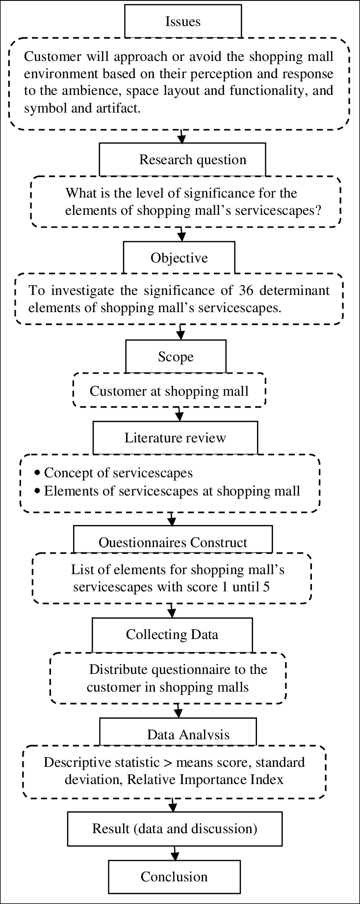

Fig. Research Methodology flow chart of shopping mall management system.
The research methodology of shopping mall management customer will approach the environment. This article is a contemporary research because it has a discipline in design, build and solution from the analysis that using the updated data. It’s about measurement for elements of shopping mall’s Service. Servicescapes is noteworthy as it is one of the factors that can attract the customers or can make them keep away from visiting the mall based on ambience conditions, layout and function space, and symbols and artifacts. Among the issues arise are unappealing atmosphere, the condition of internal facilities, lack of parking and disable facilities, unattractive arrangement layout, and fewer attractions and characterless of landscape and theme. All of this will affect the customer’s perception. Thus, this paper aimed to determine the elements in three factor of shopping mall’s service scapes that contribute to the welcoming of customer to the shopping mall. A questionnaire survey was conducted to investigate the significance of 36 determinant elements of shopping mall’s service scapes that have been identified through literature review. Finding from the analysis indicated that all determinant elements were significance in contributing to the welcoming customer to the shopping. Good parking facilities – Malls offer good parking facilities to people and it becomes easier for people to travel by their own vehicle. But this is not always the case in all the malls as there are malls where you can face problem regarding the parking facility Services provided by the staff- the staff is considered efficient , some people feel that they are helpful but some feel that the staff in these malls don’t respond well . But most of the them had a neutral opinion. Food in malls Food courts in malls are preferred by a lot of people because these food courts offers a lot of variety and could be easily accessed but there are complains about the high prices quoted for these food items yet 32% of people opted for food courts over individual restaurants A lot of people do prefer individual restaurants , about 44% people would choose restaurants. These restaurants are more economical and if they have any specific preference then they would go to these restaurants Around 24% don’t mind any of the two , for them it depends on the situation. The suggestions given by the respondents are as follows. Certain malls do not consider middle income groups. Better and cheaper parking facilities. Provide a better food court. Should introduce more fun activities and games. More brands providing offers and discounts. More taco bell branches. Security in malls- security measures taken by the malls are good enough but could be improved. Good advertisement media – Malls are also considered as a good advertising media . Films , any new products launched are promoted in malls , a way of addressing a larger audience. Methods of research - Surveys: fact finding study. Method of research involving collection of data directly for a population or a sample. - Case study: in depth comprehensive study of a person, a social group, an episode, a process, a situation or any other social unit. Scope of the study The scope of the study is within Bangalore city. All malls in Bangalore only are taken for research. Methods of research - Surveys: fact finding study. Method of research involving collection of data directly for a population or a sample. - Case study: in depth comprehensive study of a person, a social group, an episode, a process, a situation or any other social unit. Shopping mall is a group of retail stores under one roof. Malls have been constantly adapting and changing in both style and substance in order to attract increasingly sophisticated and fickle consumers. There are various factors which might affect shoppers’ selection of a place.
CHAPTER 7
SNAPSHOTS
In the computer the system, a snapshot is the state of a system at a particular point in time. The term was coined as an analog to that in photography. It can refer to an actual copy of the state of the system or to a capability provided by certain systems.
7.1 Home Page

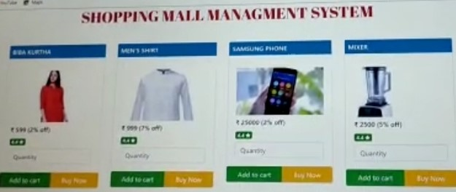
Fig 7.1 Home Page

Description: The following home page which describes that having the items which are arranged in an order in which it is having some information about the items like biba kurtha, men’s shirt, Samsung phone, mixer. The present study is an attempt in this regard with special reference to Indian context. The objective of this study was to identify the factors affecting selection criterion of consumers with respect to shopping malls. Mall intercept survey was conducted to identify the factors which influence the selection of shopping malls in multiple cities. A shopping mall's sales marketing plan describes the strategies the mall management will deploy to attract and retain tenants and to bring in more shoppers to these stores. Preparing a plan is critical to success because shopping malls compete with each other and with other retail clusters, such as shopping centers. the items which are arranged in an order in which it is having some information about the items like biba kurtha, men’s shirt, Samsung phone, mixer. The items are we should mention the item ID, item name, item image, item price and the item discount. The home page which consists of the above items in the system. The mall items having some of the items in the shops.

7.2 View Table Structure

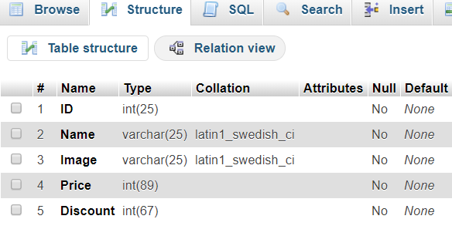
Fig 7.2 Table Structure page

Description: The structure page which consists of the names and the datatype which should be given to the items. The names which should be given to the items are we should mention the item ID, item name, item image, item price and the item discount. The datatype used for item ID is integer that is int. The datatype used for item name is variable character that is varchar. The datatype used for item image is variable character that is varchar. The datatype used for price is integer that is int. The datatype used for discount is integer that is int. The structure page which includes that datatype which should be given for the given items ID, name, image, discount, price. There is no null values given for these table structure. The default value should be of none values. Total seven factors which influence the selection of shopping malls from consumer’s view point were identified with a structure questionnaire. Study will help the mall owners and the retail marketers to understand the insights of shoppers that on what basis consumers select the shopping malls for shopping. On these bases, they can plan their strategies for shopping malls. Shopping mall is a group of retail stores under one roof. Malls have been constantly adapting and changing in both style and substance in order to attract increasingly sophisticated and fickle consumers. There are various factors which might affect shoppers’ selection of a place to shop. The present study is an attempt in this regard with special reference to Indian context. The structure page which consists of the names and the datatype which should be given to the items. The names which should be given to the items are we should mention the item ID, item name, item image, item price and the item discount. The datatype used for item ID is integer that is int.

7.3 View Insertion
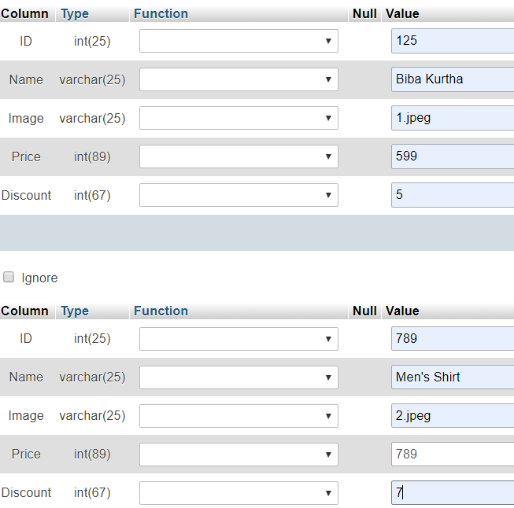
Fig 7.3.1 Insertion Page

Description: The following insertion page which consists of the table which is having the table in column and row wise. In column it consists of ID, Name, Image, Price, Discount of the two given items like Biba kurtha and Men’s shirt. In row it consists of values of the given items.
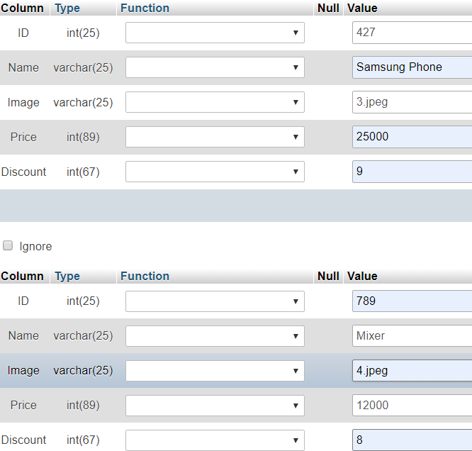

Fig 7.3.2 Insertion Page

Description: The following insertion page which consists of the table which is having the table in column and row wise. In column it consists of ID, Name, Image, Price, Discount of the two given items like Samsung phone and Mixer. In row it consists of values of the given items. There is no null values given for these table structure. The default value should be of none values. Total seven factors which influence the selection of shopping malls from consumer’s view point were identified with a structure questionnaire. Study will help the mall owners and the retail marketers to understand the insights of shoppers that on what basis consumers select the shopping malls for shopping.

7.5 View Items

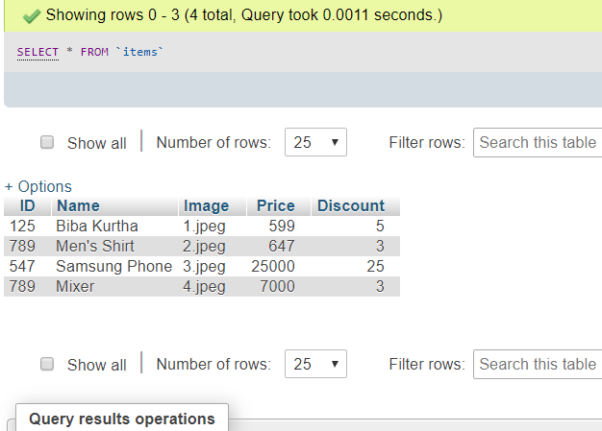

Fig 7.5 Item Description Table

Description: The following table gives the description of the items that we are inserted in the query. In this table we can know about the item ID, item name, item images, item price and the discount of the each items that we are mentioned in the table. In this table we get the query result operation. Totally 4 rows are inserted the rows which are from 0 to 3. In this we got to know about how much time did the query took. From the above table the query took 0.0007 seconds. There is no null values given for these table structure. The default value should be of none values. Total seven factors which influence the selection of shopping malls from consumer’s view point were identified with a structure questionnaire. Study will help the mall owners and the retail marketers to understand the insights of shoppers that on what basis consumers select the shopping malls for shopping. The objective of this study was to identify the factors affecting selection criterion of consumers with respect to shopping malls. Mall intercept survey was conducted to identify the factors which influence the selection of shopping malls in multiple cities.

CHAPTER 8
CONCLUSION
In this project we have used database management system to store the data and retrieve the data. Here the XAMPP tool is used for server and database. The XAMPP tool provides Apache server, MySql database, Filezilla application, Mercury server, Tomcat. We have used the Apache server and MySql database. The database is used as backend and php, html, javascript are used as front end. Here there is no modifying of code everytime to enter or modify the details of product. This is the time consuming method and easiest method to insert new products or modify the products.
This is the user friendly to use this method. XAMPP is a free and open-source cross-platform web server solution stack package developed by Apache Friends, consisting mainly of the Apache HTTP Server, Maria DB database, and interpreters for scripts written in the PHP and Perl programming languages. Since most actual web server deployments use the same components as XAMPP, it makes transitioning from a local test server to a live server possible.

CHAPTER 9
REFERENCES
[1] JavaScript Enlightenment, Cody Lindley-First Edition, based on JavaScript 1.5,
ECMA-262, Edition.
[2] Complete CSS Guide, Maxine Sherrin and John Allsopp-O'Reilly Media; September
2012.
[3] Mc GrawHill’s, Java: The complete reference 7thEdition, Herbert Schildit.
[4] http://www.w3schools.com
[5] https://www.tutorialspoint.com
[6] https://www.ionos.com

